**User Perception for Food Image: Summary**

## User Study:

We performed a user study with **N=202** (35% female) that give rating to **200** recipes in terms of how the recipes pictures is attractive in addition to how user perceive the attractiveness in terms of judgment.

**The Proposed Research Questions:**

The average rating distribution for images show in figure bellow:

**[RQ1] How do user demographics, food knowledge, and recipe healthiness contributes, food category to the user perception of food images?**

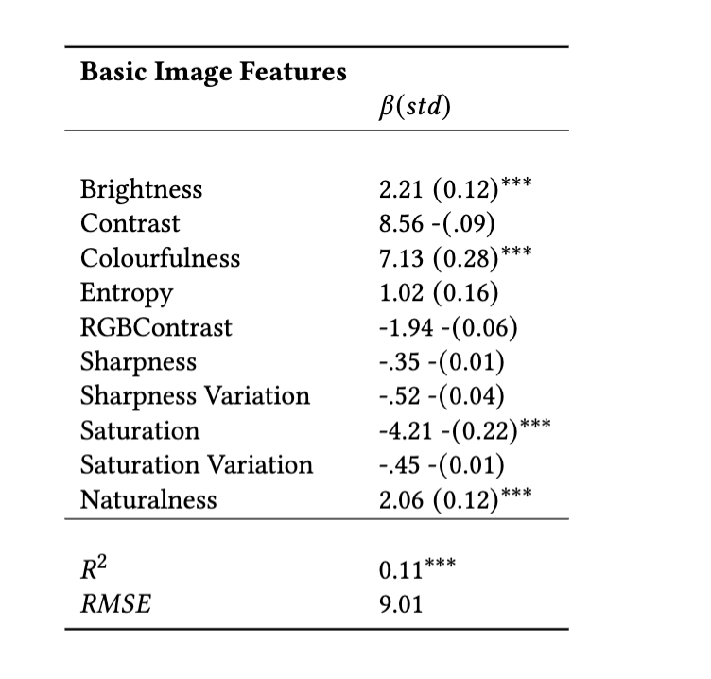From the literature it has been found that basic image features have a significant predicted power for the image attractiveness. In the same direction, the result of a hierarchical linear model shows that **Brightness, Colorfulness, Saturation** and **Naturalness** are significant features that affect the image attractiveness as shown in table below:

We extracted high level image features using three different stat of the art deep learning models **VGG16, ResNet,** and **ClipOpenAI**. To compare those features, we used three linear models to predict the attractiveness of a recipe image in terms of ratings. Results are shown in table below:

The next phase we use the user feature to predict the attractiveness of recipes images, overall, **cooking skills** is the only user factor that is significantly correlated with how user react to recipes image attractiveness. Table below shows the results of a linear model to predict user attractiveness in terms ratings.

The next steps is to investigate how the healthiness measure with **FSA score** affects the attractiveness:

**[RQ2] To what extent do different human food factor choices contributes to user perception?**

In this research question we asked participant to state which of food choices factor effect their recipes image ratings, including recipe **appearance, taste, healthiness or familiarity.**

**[RQ2] How people judge the recipes image attractivness?**

To do so I have looked and categorized the recipes into attractive and non-attractive based on a rating threshold. And I showed a word cloud for what user said.

**Attractive Judgment**

**Unattractive Judgment**